
KAMPALA, UGANDA, EAST AFRICA
9 – 11 DECEMBER 2026
www.conference.nbrb.go.ug

Paper Title (use style: paper title)
Author Name¹∗, Author Name² and Author Name³
1 Department, Institution, City, Country
2 Department, Institution, City, Country
3 Department, Institution, City, Country
Abstract. This document is a “live” template and already defines the components of your paper in its style sheet. Insert your abstract here. The abstract should briefly cover the background, methodology, key quantitative results, and the main conclusions. When formatting the abstract, apply an italic style to the run-in head (the word "Abstract") to differentiate it from the rest of the text. Critical Guidelines for Authors include: (1) do not use symbols, special characters, footnotes, or math in the Abstract or the Paper Title. (2) footnotes must be placed at the bottom of the page in which they are cited and should never be put in the abstract; and (3) if you define abbreviations and acronyms within the abstract, you must define them again the first time they are used in the main text. Note that the Author Name should be in order of: First Name, Middle Name (if any), Surname. Please ensure that your abstract is clear, concise and does not exceed a maximum word count of 200 words.
Keywords: Immediately following the abstract, provide 3-5 keywords separated by commas (e.g., Green Building Materials, Circular Materials, Sustainable Construction, Pozzolanic Materials).

INTRODUCTION (HEADING 1)
All standard paper components have been specified for three reasons: (1) ease of use when formatting individual papers, (2) automatic compliance to electronic requirements that facilitate the concurrent or later production of electronic products, and (3) conformity of style throughout conference proceedings. Margins, column widths, line spacing, and type styles are built-in; examples of the type styles are provided throughout this document and are identified in italic type, within parentheses, following the example. Additional manuscript components, such as multi-levelled equations, graphics, and tables are prescribed. The formatter will need to create these components, incorporating the applicable criteria that follow. Please ensure that the full manuscript is limited between 10 and 15 pages.
Within the introduction section, provide the background, rationale, and objectives of your study. Frame the scientific problem within the conference theme and your specific sub-theme. For instance, under sub-theme “Innovations in Construction Materials and Practices”, discuss context, such as Uganda’s rapid urbanization and the subsequent need for decarbonization and sustainable building practices. Following a concise but robust literature review, articulate the expected novelty or the significance of the work; and state the primary aim of the paper.

Maintaining the Integrity of the Specifications (Heading 2)
The template is used to format your paper and style the text. All margins, column widths, line spaces, and text fonts are prescribed; please do not alter them. You may note peculiarities. For example, head margin measures proportionately more than customary. This measurement and others are deliberate, using specifications that anticipate your paper as one part of the entire proceedings, and not as an independent document. Please do not revise any of the current designations.

Using the Template (Heading 2)
After the text edit has been completed, the paper is ready for the template. Duplicate the template file by using the “Save As” command, and use the naming convention as prescribed by the accepted Abstract ID for the name of your paper. In this newly created file, highlight all of the contents and import your prepared text file. You are now ready to style your paper; use the scroll down window on the left of the MS Word Formatting toolbar.

Authors and Affiliations
The template is designed for, but not limited to, three authors. A minimum of one author is required for all conference articles. Author names should be listed from the left to right before moving down to the next line. Please keep your affiliations as succinct as possible. For papers with more than three authors, add author names; and for papers with less than three authors, delete the author and affiliation lines for the extra authors.

Identify the Headings
Headings are organizational devices that guide the reader through your paper. In your manuscript, please follow the format of headings used in this template.

METHODOLOGY (HEADING 1)

Guidelines for Authors (Heading 2)
In this Section, detail the experimental or numerical techniques with high methodological rigor. Describe the sourcing and preparation of all materials. Explicitly cite the testing standards utilized (e.g., ASTM D570 for water absorption, ASTM E986 for SEM morphology, ASTM C67 for brick testing procedures etc). If your study utilizes a mixed-methods approach (questionnaires, interviews, laboratory testing), outline the sample frame, study area (location), and timeline. Ensure the manuscript comprehensively includes complete empirical methods.

Prepare Your Paper Before Styling (Heading 2)
Before you begin to format your paper, first write and save the content as a separate text file. Complete all content and editing before formatting. Keep text and graphic files separate until after the text has been formatted and styled. Do not use hard tabs, and limit use of hard returns to one return at the end of a paragraph. Do not add any kind of pagination anywhere in the paper. Do not number text heads as the template will do that for you. The following Sections provide more information on proofreading, spelling and grammar.

Abbreviations and Acronyms (Heading 3)
Define abbreviations and acronyms the first time they are used in the text, even after they have been defined in the abstract. Do not use abbreviations in the title or heads unless they are conventional and unavoidable.

Units (Heading 3)
Use of SI as primary units is encouraged. English units may be used as secondary units (in parentheses). Avoid combining SI and any other unit conventions, as it often leads to confusion for the reason that equations do not balance dimensionally. When writing use a zero before decimal points: “0.25”, not “.25”.

Equations (Heading 3)
The equations are an exception to the prescribed specifications of this template. You will need to determine whether or not your equation should be typed using either “Cambria Math” or Symbol font (please no other font). To create multileveled equations, it may be necessary to treat the equation as a graphic and insert it into the text after your paper is styled.
Number equations consecutively. The equation number should be positioned flush right, within parenthesis, as in Equation (1). Italicize all symbols for quantities and variables. Use a long dash rather than a hyphen for a minus sign. Punctuate equations with commas or periods when they are part of a sentence, as in the following example:
 | $$x=\frac{-b±\sqrt{b^{2}-4ac}}{2a}$$ | (1)
Note that the equation is centred. Be sure that the symbols in your equation have been defined before or immediately following the equation. Use “(1)”, not “Eq. (1)” or “equation (1)”; except at the beginning of a sentence, wherein use “Equation (1) is . . .”

RESULTS (HEADING 1)
Present your empirical data clearly using text, tables, and high-quality figures. Provide specific, quantitative findings.

Figures and Tables (Heading 2)
Insert figures and tables after they are cited in the text. When citing tables, use “Table 1”; and use the abbreviation “Fig. 1” when referring to a figure, even at the start of a sentence. Adapt the template of Table 1 in which the caption is inserted at the top of the table. Copy and paste the whole text box to add more tables. Place tables close to where they are cited in the text. Insert the table footnotes (if any) immediately at the bottom of the table.
On the other hand, use words rather than symbols or abbreviations when writing figure axis labels to avoid confusing the reader. If including units in the label, present them within parentheses. Do not label axes with a ratio of quantities and units. The figure captions should be inserted at the bottom of the figure.

Example of table (Heading 3)
All tables shall strictly conform to the example Table 1 template. Authors should maintain consistency in table layout, captions, headings, statistical notation, footnotes, and formatting to ensure a uniform appearance across all manuscripts.
Table 1. Replace this text with the table caption.
Table Heading | Table Column Heading |  | Column Heading (%)
Table Heading | Column sub-headingª | Column sub-heading | Column Heading (%)
copy | More table copy | 52.03 | 29.84
copy | More table copy | 52.03 | 29.84
copy | More table copy | 17.50 | 47.30
ª Table footnote.

Example of table (Heading 3)
Combining related or supplementary figures into a single graphic with sub-labels like (a) and (b) is a standard and effective practice (e.g., as shown in Fig. 1), is encouraged. When combining figures and formatting their captions in your manuscript, you should adhere to the following template guidelines. Otherwise, figures can be presented separately.
(a) | (b)
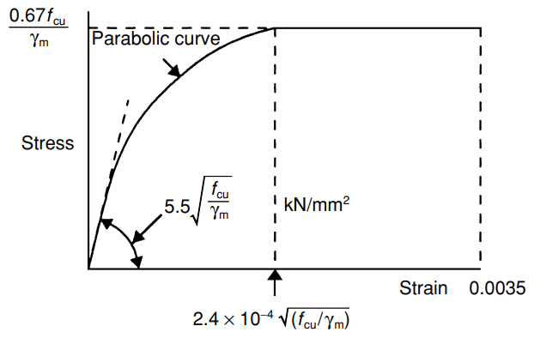 | 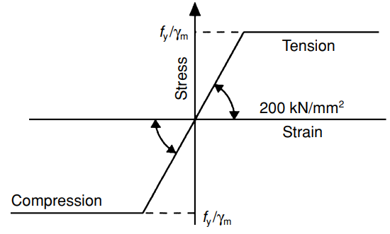
Fig. 1. Insert figure caption here [e.g., Design stress–strain curve for (a) concrete in compression; and (b) reinforcing steel]. If the figure is extracted from published literature, cite the source (e.g., BS 8110).

Additional Guidance for Figures and Tables (Heading 3)
- Font Size: All text within figures, graphs, charts, and diagrams should be clearly legible, with a minimum font size of 8 pt after final scaling.
- Colour and Grayscale: Coloured figures are encouraged for the electronic version of the proceedings; however, authors must ensure that all figures remain clear and interpretable when printed in grayscale.
- Acceptable File Formats: Figures should be submitted in TIFF, EPS, PNG, or JPEG format. Vector graphics (e.g., EPS or PDF) are preferred for line drawings and diagrams to preserve image quality.
- Resolution: Photographs and other raster images should have a minimum resolution of 300 dpi, while line drawings, graphs, and diagrams should have a minimum resolution of 600 dpi (preferably 1200 dpi) to ensure high-quality reproduction.
- Figure Size: Figures should be sized to fit within the page layout and may span the full-page width, provided they remain clear, readable, and are placed as close as possible to their first citation in the text.

DISCUSSION (HEADING 1)

Guidelines for Authors (Heading 2)
Interpret your results and compare them with standard regulatory frameworks, such as British Standards Institution (BS EN 771), and similar trends in published literature. Endeavour to explain the scientific theories supporting the results presented. In addition, discuss practical and economic implications of your findings. If your study developed a framework or "decision matrix" for adoption, detail its practical applicability for industry stakeholders here.

Some Common Mistakes (Heading 2)
- The word “data” is plural, not singular.
- Do not use the word “essentially” to mean “approximately” or “effectively”.
- Do not confuse “imply” and “infer”.
- The prefix “non” should be joined to the word it modifies, usually without a hyphen.
- There is no period after the “et” in the abbreviation “et al.”.

CONCLUSION AND POLICY RECOMMENDATIONS (HEADING 1)
Summarize the key findings without simply repeating the abstract. Emphasize the policy relevance of your work. Explain how your material or practice advances sustainable regulatory frameworks toward building control. Strengthen by providing actionable recommendations for integrating the innovations into low-carbon building codes and circular economy strategies.
Acknowledgements
Acknowledge any individuals, organizations, or data providers who assisted with the research but do not meet authorship criteria based on intellectual contribution.
Disclosure Statement
State any financial interest or benefit that has arisen from the direct applications of your research. If none, state: "No potential conflict of interest was reported by the author(s)."
Funding
List any funding agencies and grant numbers that supported this research. If none, state: "No funding was received by the author(s)."
Author Contributions
Contributions may include, but are not limited to: conceptualization, methodology, investigation, data curation, formal analysis, software, validation, visualization, original draft preparation, review and editing, supervision, project administration, and funding acquisition. Each listed author should have made a substantial intellectual contribution to the work and should have reviewed and approved the final manuscript before submission.

REFERENCES (HEADING 1)
Strictly use the APA 7th Edition reference style as the specified style for the conference proceedings. Ensure all citations in the text are listed here, and all listed references are cited in the text. Use of a referencing tool is highly encouraged. The “Example APA format” is shown:
Author, A. A., and Author, B. B. (Year). Title of the article. Title of the Journal, Volume (Issue), Page range. DOI: insert the webpage link
Author, C. C., and Author, D. D. (Year). Title of the article. Title of the Journal, Volume (Issue), Page range. DOI: insert the webpage link
Author, E. E., and Author, F. F. (Year). Title of the article. Title of the Journal, Volume (Issue), Page range. DOI: insert the webpage link

GENERAL FORMATTING
The complete manuscript, including references, should be 10–15 pages (approximately 5000-7000 words). Authors must use the predefined template without modifying the prescribed margins, page layout, spacing, tables, figures or heading styles to ensure consistency and uniformity. Though the styles are built into this document, please ensure that your base text remains in 12-pt “Source Sans Pro” and is single-spaced throughout. This acts as a fail-safe in the event that copying and pasting external text accidentally overwrites the built-in template styles. As noted previously in the styling instructions, do not add any kind of pagination in the manuscript.

∗ Corresponding Author (insert first name, middle name [if any], surname) - E-mail: name@institution.ac.ug

